**Supplementary Material**

**Appendix I. DNA Extraction Protocols**

*ACWG:*

Samples from rhino horn were obtained by drilling into the side or the base of the specimen and collecting the drill shavings from the core of the horn, following sampling procedures outlined by Harper et al. [1]. Ten to 20 hair follicles were cut and separated from the whole hair samples. Bone and skin samples required a pre-extraction re-hydration step by immersing approximately 2 mm3 of each subsample in 1000 μL phosphate buffered saline (PBS) for 4-5 hours. Bone samples were decalcified prior to gDNA extraction following the decalcification protocol outlined by Mailand and Wasser [2]. DNA was extracted from the ‘low template’ horn, hair and skin samples in a separate clean room facility using the ‘QIAamp DNA Investigator’ extraction kit (QIAGEN GmbH), 'Isolation of total DNA from chewing gum’ protocol with 1 μL (1 μg) of dissolved carrier RNA added to Buffer AL. A slight modification to the 'Isolation of total DNA from chewing gum’ protocol was made for the horn samples: samples were lysed overnight (instead of the recommended 3 hours) at 56°C shaking at 900 rpm to ensure full lysis of the hard keratin structure.

Genomic DNA was extracted from tissue, blood, faeces, bone and the human buccal swabs using the ‘DNeasy Blood & Tissue DNA’ extraction kit (QIAGEN GmbH), ‘Animal tissues’ protocol.

*Flinders University:*

Cow DNA was isolated from a tissue sample by placing approximately 10 mg of material into a 1.5 mL tube. Extraction followed the QIAamp DNA Investigator’ extraction kit for ‘Tissue’ (QIAGEN, VIC, AU) method with some modifications. For lysis, 390 μL of Buffer ATL and 10 μL of 10 mg/mL proteinase K was incubated at 50 oC for 1 hour or until all material was dissolved. Elution was into 100 μL AE buffer

Horn was treated by cutting sections into a 1.5 mL micro-centrifuge tube. Extraction followed the QIAamp DNA Investigator’ extraction kit (QIAGEN, VIC, AU) 'Isolation of total DNA from hair’ method with some modifications. For lysis, 380 μL of Buffer ATL, 10 μL10 mg/mL proteinase K and 10 μL 1 mM DTT was incubated at 50 oC for 1 hour or until all material was dissolved. Elution was into 50 μL AE buffer.

Human DNA was isolated from a buccal swab (SBREC 7560 approval) following the QIAamp DNA Investigator’ extraction kit (QIAGEN, VIC, AU) 'Isolation of total DNA from buccal swab’ method. The process was the same for the isolation of cow DNA.

*SASA:*

Genomic DNA was extracted from tissue and blood samples using the ‘DNeasy Blood & Tissue DNA’ extraction kit (QIAGEN). For horn samples, approximately 20 mg of horn shavings were extracted using the same kit but with some modifications. For lysis, 380 μL of ATL buffer, 20 μL of proteinase K, and 10 μL of 1 mM DTT were added to the horn shavings for overnight incubation at 56 oC at 900 rpm. Subsequent additions of AL (400 μL) and ethanol (400 μL) were similarly increased from standard. Elution was into 50 μL AE buffer.

*IEBR:*

Approximately 20 mg of rhino horn shavings were obtained by drilling into the side or the base of the specimen. Genomic DNA was extracted from the horn samples using the ‘QIAamp DNA Investigator’ extraction kit (QIAGEN GmbH), 'Isolation of total DNA from chewing gum’ protocol, with some modifications. For lysis, 300 µL Buffer ATL, 20 µL proteinase K, and 20 µL 1 M DTT were added to the horn shavings for overnight incubation at 56 oC at 900 rpm.

*WIFOS:*

Horn samples were drilled and homogenized into a powder using an engraving dill bit. Approximately 100 mg of horn was extracted using the Nucleospin Tissue DNA extraction kit (Macherey-Nagel, GmbH & Co. KG) with some modifications. The recommended volumes for all reagents were doubled, and 10 μL of 1M DTT was added before lysis.

**Appendix II. PCR amplification and DNA sequencing**

*ACWG:*

PCRs for each amplification were performed in a 25 μL reaction containing 1 x Bioline MyTaq Red Reagent Buffer, 0.2 μM of both the forward and reverse primer, 1 unit of Bioline MyTaq DNA Polymerase and genomic DNA of varying concentration. Negative controls were included. PCR products were purified using ExoSap-IT (USB Corporation, OH, USA). Purified amplicons were sequenced at the Australian Genome Research Facility (AGRF) using Applied Biosystems 3730 and 3730xl capillary sequencers.

*Flinders University:*

For the confirmation test (section 2.3.1), PCRs for each amplification were performed in a 25 μL reaction containing 2 x QIAGEN Multiplex Buffer (QIAGEN), 0.2 μM of both the forward and reverse primer and template DNA at varying concentrations. For the mixed samples experiment (section 2.3.2), amplifications were performed using the QIAGEN Hot Start enzyme in a 20 µL reaction containing 1 X QIAGEN buffer, 0.1 mM dNTPs, 0.5 mM of each primer, and DNA template at 1 ng of white rhino DNA and varying amounts of bovine and human DNA. Amplification was performed in a ProFlex thermalcyler (ThermoFisher). Negative and positive controls were included. PCR products were treated with ExoSAP (VWR, VIC, AUS) by adding 2 μL ExoSAP to 5 μL PCR product and incubating at 37 oC for 30 minutes then at 85 oC for 5 minutes. Purified amplicons were sequenced at the AGRF using Applied Biosystems 3730 and 3730xl capillary sequencers.

*SASA:*

PCRs were performed in a 20 μL reaction volume containing 10 μL Type-it Multiplex PCR Master Mix (QIAGEN), 0.5 μM of both the forward and the reverse primer and genomic DNA of varying concentration (≤10 ng/μL). The cycling was performed on a ProFlex™ PCR system (Applied Biosystems). PCR products were purified using Exonuclease I with Shrimp Alkaline Phosphatase digestion. Sequencing reactions were performed in both forward and reverse directions using BigDye® Terminator v3.1 chemistry (Applied Biosystems) and sequenced in house using a 3500 series Genetic Analyzer (Applied Biosystems). Positive and negative controls were included at all steps in the process.

*IEBR:*

PCRs for each amplification were performed in a 10 μL reaction containing 8 μL of Maxima Hot Start PCR Master Mix (ThermoFisher), 1 μM of both the forward and reverse primer and template DNA at varying concentrations. The cycling was performed on a peqSTAR 96 Univeral Gradient PCR system (PEQLAB). Negative controls were included. PCR products were purified using ExoSAP. Purified amplicons were sequenced at Macrogen using an Applied Biosystems 3730xl capillary sequencer.

*WIFOS:*

PCRs for each amplification were performed in a 20 μL reaction containing 14 μL of Maxima Hot Start Maser Mix (ThermoFisher), 1 μM of each primer and template DNA at varying concentrations. The cycling was performed on a ABI Veriti Instrument (ThermoFisher). PCR products were purified using Nucleospin PCR clean up (Macherey-Nagel, GmbH & Co. KG). Purified amplicons were sequenced using BigDye® Terminator v3.1 chemistry (Applied Biosystems) and sequenced in house using a 3500 series Genetic Analyzer (Applied Biosystems). Positive and negative controls were included at all steps in the process.

**Table S1.** Sample details for specimens of known species, and corresponding species identification success.

|  |  |  |  |  |  |
| --- | --- | --- | --- | --- | --- |
| **Sample Name** | **GenBank accession number** | **Species** | **Sample origin** | **Sample type** | **Successful amplification and correct species identification result** |
| M.47191.001 V, P, R, A | MF998117 | *Ceratotherium simum* (white rhino) | Zoo collection | Blood Clot | **Yes** |
| M.47190.001V, P, R | MF998118 | *Ceratotherium simum* (white rhino) | Zoo collection | Blood Clot | **Yes** |
| EBU:90737 V, R | MF998119 | *Ceratotherium simum* (white rhino) | Zoo collection | Horn fibres | **Yes** |
| EBU:90697 V, R, T | MF998123 | *Ceratotherium simum* (white rhino) | Zoo collection | Hair | **Yes** |
| EBU:90704 V, R | MF998122 | *Ceratotherium simum* (white rhino) | Zoo collection | Hair | **Yes** |
| EBU:90717 V, R | MF998121 | *Ceratotherium simum* (white rhino) | Zoo collection | Horn | **Yes** |
| EBU:90695 V, R | MF998124 | *Ceratotherium simum* (white rhino) | Zoo collection | Horn | **Yes** |
| EBU:90722 V, R | MF998120 | *Ceratotherium simum* (white rhino) | Zoo collection | Horn fibres | **Yes** |
| M.46283.001 R | MF998114 | *Ceratotherium simum* (white rhino) | Museum collections | Faeces | **Yes** |
| M.46284.001 R | MF998115 | *Ceratotherium simum* (white rhino) | Museum collections | Faeces | **Yes** |
| RH127_SASA V, S | MF998116 | *Ceratotherium simum* (white rhino) | Zoo collection | Blood | **Yes** |
| RC_B10 M | MF998125 | *Ceratotherium simum* (white rhino) | Zoo collection | Horn | **Yes** |
| M.47202.001 V, P, R | MF998136 | Diceros bicornis (black rhino) | Zoo collection | Blood | **Yes** |
| M.46281.001 V, P, R, A | MF998128 | Diceros bicornis (black rhino) | Museum collections | Tissue | **Yes** |
| M.46278.013 V, P, R | MF998127 | Diceros bicornis (black rhino) | Museum collections | DNA | **Yes** |
| M.46288.001 V, P, R | MF998131 | Diceros bicornis (black rhino) | Museum collections | DNA | **Yes** |
| M.46292.001 V, P | MF998132 | Diceros bicornis (black rhino) | Museum collections | DNA | **Yes** |
| M.46293.014 V, P, R | MF998133 | Diceros bicornis (black rhino) | Museum collections | DNA | **Yes** |
| EBU:90644 | MF998135 | Diceros bicornis (black rhino) | Zoo collection | Horn | **Yes** |
| EBU:90723 R | MF998134 | Diceros bicornis (black rhino) | Museum collections | Hair | **Yes** |
| M.46282.001 R | MF998129 | Diceros bicornis (black rhino) | Museum collections | Faeces | **Yes** |
| M.46285.001 R | MF998130 | Diceros bicornis (black rhino) | Museum collections | Faeces | **Yes** |
| M.47204.001 V, R, T | MF998137 | Diceros bicornis (black rhino) | Zoo collection | Blood | **Yes** |
| K56_SASA V | MF998126 | Diceros bicornis (black rhino) | Zoo collection | Horn | **Yes** |
| RH162_SASA V, S | MF998138 | Diceros bicornis (black rhino) | Zoo collection | Horn | **Yes** |
| M.39431.001 V, R, A | MF998141 | *Rhinoceros unicornis* (Indian rhino) | Museum collections | Tissue | **Yes** |
| M.39432.005V, R, T | MF998139 | *Rhinoceros unicornis* (Indian rhino) | Museum collections | Tissue | **Yes** |
| M.39432.003(a) R | MF998140 | *Rhinoceros unicornis* (Indian rhino) | Museum collections | Skull | **Yes** |
| RH156_SASA V, S | MF998142 | *Rhinoceros unicornis* (Indian rhino) | Zoo collection | Tissue | **Yes** |
| M.2015.002 | MF998145 | *Dicerorhinus sumatrensis* (Sumatran rhino) | Museum collections | Pelvic bone | **Yes** |
| M.2006.001 | N/A | *Dicerorhinus sumatrensis* (Sumatran rhino) | Museum collections | Skin from mount | **No result** |
| B.5448.002(b) R | MF998144 | *Dicerorhinus sumatrensis* (Sumatran rhino) | Museum collections | Pelvic bone | **Yes** |
| RH019_SASA | MF998146 | *Dicerorhinus sumatrensis* (Sumatran rhino) | Museum collections | Horn | **Yes** |
| SR01 V, P | JF290491.1 | *Dicerorhinus sumatrensis* (Sumatran rhino) | Laboratory collections | Blood | **Not tested with the RID_FWD/RID_REV primers** |
| SR02 V, P | JF290492.1 | *Dicerorhinus sumatrensis* (Sumatran rhino) | Laboratory collections | Blood | **Not tested with the RID_FWD/RID_REV primers** |
| SR03 V, P | JF290493.1 | *Dicerorhinus sumatrensis* (Sumatran rhino) | Laboratory collections | Blood | **Not tested with the RID_FWD/RID_REV primers** |
| SR04 V, P | JF290494.1 | *Dicerorhinus sumatrensis* (Sumatran rhino) | Laboratory collections | Blood | **Not tested with the RID_FWD/RID_REV primers** |
| SR05 V, P | JF290495.1 | *Dicerorhinus sumatrensis* (Sumatran rhino) | Laboratory collections | Blood | **Not tested with the RID_FWD/RID_REV primers** |
| M.210.001 | N/A | *Rhinoceros sondaicus* (Javan rhino) | Museum collections | Skin from mount | **No result** |
| M.220.002 | N/A | *Rhinoceros sondaicus* (Javan rhino) | Museum collections | Skull | **No result** |
| RH039_SASA | MF998143 | *Rhinoceros sondaicus* (Javan rhino) | Museum collections | Horn | **Yes** |
| M.47998.001 | MF998147 | *Bubalus bubalis* (water buffalo) | Zoo collection | Blood | **Yes** |
| M.47999.001 | MF998148 | *Bubalus bubalis* (water buffalo) | Zoo collection | Blood | **Yes** |
| M.48000.001 | MF998149 | *Bubalus bubalis* (water buffalo) | Zoo collection | Blood | **Yes** |
| M.48005.001 | MF998150 | *Bubalus bubalis* (water buffalo) | Zoo collection | Blood | **Yes** |
| NC_B11 M | N/A | *Bos taurus* (domestic cow) | Laboratory collections | Tissue | **No result** |
| WDF093-A0400 | N/A | *Bos taurus* (domestic cow) | Carving from a seizure | Horn | **No result** |
| M.47131.001 | MF998151 | *Equus ferus* (horse) | Museum collections | Tissue | **Yes** |
| Human_1 | N/A | *Homo sapiens* (human) | N/A | Buccal swab | **No result** |
| Human_2 | N/A | *Homo sapiens* (human) | N/A | Buccal swab | **No result** |
| Human_3 | N/A | *Homo sapiens* (human) | N/A | Buccal swab | **No result** |
| Human_4 | N/A | *Homo sapiens* (human) | N/A | Buccal swab | **No result** |
| FU_Human M | N/A | *Homo sapiens* (human) | N/A | Buccal swab | **No result** |
| C_simum1 P | Y07726.1 | *Ceratotherium simum* (white rhino) | GenBank | | **N/A** |
| D_bicornis1 P | FJ905814.1 | Diceros bicornis (black rhino) | GenBank | | **N/A** |
| D_bicornis2 P | NC_012682.1 | Diceros bicornis (black rhino) | GenBank | | **N/A** |
| R_unicornis1 P | X97336.1 | *Rhinoceros unicornis* (Indian rhino) | GenBank | | **N/A** |
| R_unicornis2 P | JF718877.1 | *Rhinoceros unicornis* (Indian rhino) | GenBank | | **N/A** |
| R_sondaicus1 P | AJ245725 .1 | *Rhinoceros sondaicus* (Javan rhino) | GenBank | | **N/A** |
| R_sondaicus2 P | FJ905815.1 | *Rhinoceros sondaicus* (Javan rhino) | GenBank | | **N/A** |
| D_sumatrensis1 P | NC_012684.1 | *Dicerorhinus sumatrensis* (Sumatran rhino) | GenBank | | **N/A** |
| D_sumatrensis2 P | FJ905816.1 | *Dicerorhinus sumatrensis* (Sumatran rhino) | GenBank | | **N/A** |
| B_bubalis P | D88634.1 | *Bubalus bubalis* (water buffalo) | GenBank | | **N/A** |
| B_bubalis P | D88635.1 | *Bubalus bubalis* (water buffalo) | GenBank | | **N/A** |
| B_bubalis P | D88636.1 | *Bubalus bubalis* (water buffalo) | GenBank | | **N/A** |
| B_bubalis P | D88637.1 | *Bubalus bubalis* (water buffalo) | GenBank | | **N/A** |
| B_bubalis P | D88638.1 | *Bubalus bubalis* (water buffalo) | GenBank | | **N/A** |
| H_sapiens1 P | KM360124.1 | *Homo sapiens* (human) | GenBank | | **N/A** |
| H_sapiens2 P | HE647856.1 | *Homo sapiens* (human) | GenBank | | **N/A** |
| H_sapiens3 P | JN034134.1 | *Homo sapiens* (human) | GenBank | | **N/A** |
| E_caballus | NC_001640.1 | *Equus caballus* (Horse) | GenBank | | **N/A** |

V  Voucher specimens.

P  Sequence from this sample was used in primer design (section 2.2).

R  Samples were tested multiple times in separate PCRs (section 2.3.1).

A  Samples were tested by an alternate analyst (section 2.3.1).

T  Samples were used in the temperature study (section 2.3.1).

M  Samples were used in the mixed samples experiment (section 2.3.2).

S  Samples were used in the sensitivity testing (section 2.3.3).

**Table S2.** Seizure sample details and the species identification test results from the field testing. All samples are horns or horn fragments.

|  |  |  |  |
| --- | --- | --- | --- |
| **Sample name** | **Item seized in** | **Tested by** | **Successful amplification and species identification result** |
| M.47168.001 | Australia | ACWG | **No result** |
| M.47169.001 | Australia | ACWG | **Black Rhino** |
| M.47170.001 | Australia | ACWG | **Water buffalo** |
| M.47171.001 | Australia | ACWG | **Black Rhino** |
| M.47172.001 | Australia | ACWG | **Black Rhino** |
| M.47173.001 | Australia | ACWG | **No result** |
| M.47174.001 | Australia | ACWG | **Water buffalo** |
| M.47175.001 | Australia | ACWG | **Black Rhino** |
| M.47176.001 | Australia | ACWG | **Indian rhino** |
| M.33640.001 | Australia | ACWG | **Black rhino** |
| M.33641.001 | Australia | ACWG | **Black rhino** |
| M.43471.001 | Australia | ACWG | **Black rhino** |
| M.43472.001 | Australia | ACWG | **Indian rhino** |
| M.43473.001 | Australia | ACWG | **White rhino** |
| WGM105_01 | Vietnam | IEBR | **No result** |
| WGM105_02 | Vietnam | IEBR | **White rhino** |
| WGM105_04 | Vietnam | IEBR | **Black rhino** |
| WGM105_05 | Vietnam | IEBR | **White rhino** |
| WGM105_07 | Vietnam | IEBR | **White rhino** |
| WGM105_08 | Vietnam | IEBR | **White rhino** |
| WGM105_09 | Vietnam | IEBR | **White rhino** |
| WGM105_10 | Vietnam | IEBR | **No result** |
| WGM105_11 | Vietnam | IEBR | **White rhino** |
| WGM105_12 | Vietnam | IEBR | **White rhino** |
| WGM105_13 | Vietnam | IEBR | **White rhino** |
| WGM105_14 | Vietnam | IEBR | **Black rhino** |
| WGM105_15 | Vietnam | IEBR | **White rhino** |
| WGM105_16 | Vietnam | IEBR | **No result** |
| WGM105_17 | Vietnam | IEBR | **White rhino** |
| WGM105_18 | Vietnam | IEBR | **White rhino** |
| WGM105_19 | Vietnam | IEBR | **White rhino** |
| WGM105_21 | Vietnam | IEBR | **White rhino** |
| TS_01 | Thailand | WIFOS | **White rhino** |
| TS_02 | Thailand | WIFOS | **White rhino** |
| TS_03 | Thailand | WIFOS | **White rhino** |
| TS_04 | Thailand | WIFOS | **White rhino** |
| TS_05 | Thailand | WIFOS | **White rhino** |
| TS_06 | Thailand | WIFOS | **White rhino** |
| TS_07 | Thailand | WIFOS | **White rhino** |
| TS_08 | Thailand | WIFOS | **White rhino** |
| TS_09 | Thailand | WIFOS | **White rhino** |
| TS_10 | Thailand | WIFOS | **White rhino** |
| TS_11 | Thailand | WIFOS | **White rhino** |
| TS_12 | Thailand | WIFOS | **Black rhino** |
| TS_12 | Thailand | WIFOS | **White rhino** |
| TS_14 | Thailand | WIFOS | **Black rhino** |
| TS_15 | Thailand | WIFOS | **White rhino** |
| TS_16 | Thailand | WIFOS | **White rhino** |
| TS_17 | Thailand | WIFOS | **White rhino** |
| TS_18 | Thailand | WIFOS | **White rhino** |
| TS_19 | Thailand | WIFOS | **White rhino** |
| TS_20 | Thailand | WIFOS | **White rhino** |

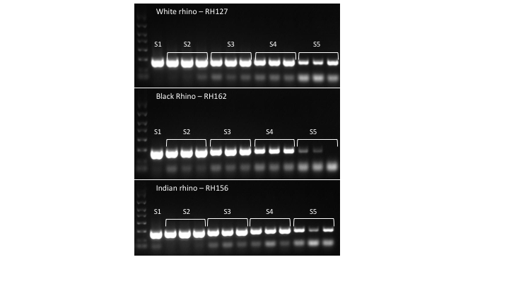

**Figure S1.** An agarose gel showing the results of the sensitivity testing. DNA from a white rhino (RH127_SASA), black rhino (RH162_SASA) and Indian rhino (RH156_SASA) was diluted to ~10 ng/µL (S1), ~1 ng/µL (S2), ~0.1 ng/µL (S3), ~10pg/µL (S4) and 1 pg/µL (S5), then amplified in triplicate via PCR using the RID_FWD/RID_REV primers.

NB: 2 µL of DNA were used in each of the PCRs.

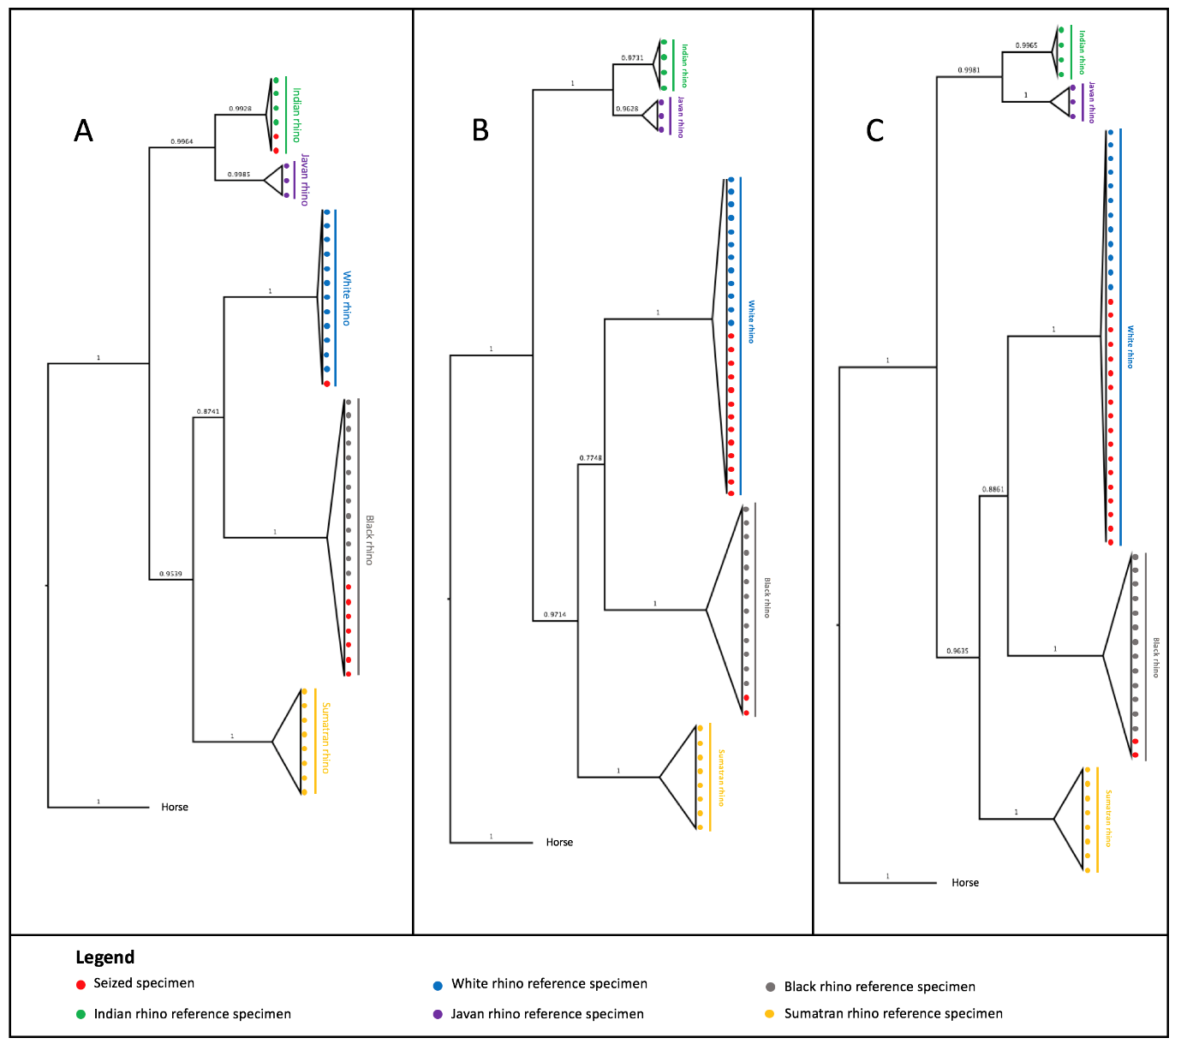

**Figure S2.** Bayesian phylogenetic trees containing known reference specimens and seized horn specimens from Australia (A), Vietnam (B) and Thailand (C). The trees were constructed using MRBAYES version 3.2 (Ronquist and Huelsenbeck, 2003), using the HKY + G site distribution model (A and C) and HKY site distribution model (B). Bayesian posterior probabilities are presented above the branches on each of the trees.

**Table S3.** The PCR success of the L14696/H15197 primers for samples that were successfully amplified in a PCR using the RID_FWD/RID_REV primers.

|  |  |
| --- | --- |
| **Sample name** | **PCR success with  L14696/H15197** |
| M.47153.001 | Yes |
| M.46281.001 | Yes |
| M.46282.001 | No |
| M.46285.001 | No |
| M.47202.001 | Yes |
| M.47204.001 | Yes |
| M.47172.001 | No |
| M.47175.001 | Yes |
| M.33640.001 | Yes |
| M.47190.001 | Yes |
| M.47191.001 | Yes |
| Human_1 | Yes |

**Supplementary Material References**

**[1]** C.K. Harper, G.J. Vermeulen, A.B. Clarke, J.I. De Wet and A.J. Guthrie, Extraction of  
 nuclear DNA from rhinoceros horn and characterization of DNA profiling systems for white (*Ceratotherium simum*) and black (*Diceros bicornis*) rhinoceros, *Forensic Sci. Int. Genet.***7** (4), 2013, 428–433.

**[2]** C. Mailand and S.K. Wasser, Isolation of DNA from small amounts of elephant ivory,  *Nat. Protoc.* **2** (9), 2007, 2228–2232.